Good news from Agonisthan (invented neologism by Richard Desjardins)
By Pierre Jasmin, artiste pour la paix 15 avril 2021
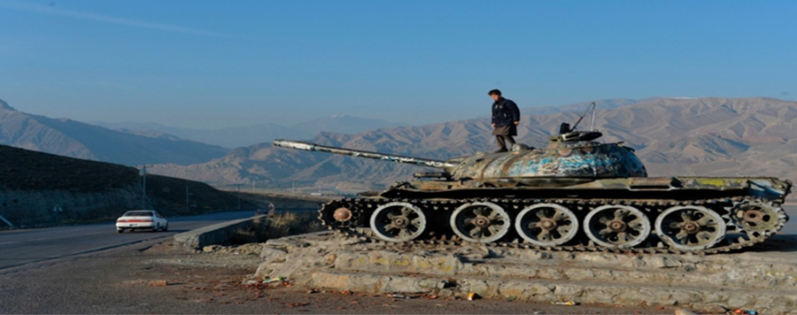
An afghan child plays on the roof of a rotting tank from the Russian 1979 invasion
Photo Noorullah Shirzada, Agence France-Presse
The French newspaper Libération (chosen for its name) reports today:
Joe Biden has confirmed that he will withdraw all U.S. soldiers from Afghanistan by the 20th anniversary of the 9/11 attack which had provoked the U.S. intervention. Although there are concerns of a Taliban win and a comeback of an avatar of the fundamentalist regime they imposed from 1996 to 2001 in Kabul, Washington has ruled that it will leave the land "without conditions."
Since the Artists for Peace Casabonne and Bussières demonstrated in the fall of 2001 in the streets of Montreal against Canadian military interference in the conflict, the United States has each year deployed troops, up to 100,000 in 2011 (under Nobel Peace Prize winner Barack Obama). U.S. President Biden's announcement thus spells the end of NATO's catastrophic Resolute Support operation, which in 2019 still had 16,500 troops deployed from 38 different countries, including 8,000 Americans, 1,300 Germans and 1,100 Britons.
France cleverly had left in 2012 after 89 deaths. When he took power, Trudeau had the good sense to withdraw Canadian troops from the waspnest where General Hillier had, with Harper's blessing, involved them ("let's kill those Afghan scumbags," was his warcry!), causing in Kandahar a great share of their 159 dead from 2001 to 2014 (no better at defending life, he has just been ejected from his Ontario shabby performance at $20,000 a month to favor COVID vaccinations).
Searchers from Brown University (a Rhode Island Ivy League member) value the total cost of the U.S. anti-jihadist wars in Iraq, Syria and Afghanistan at US$ 6400 billion, this number not even considering the costs of the CIA operations nor medical help for the tens of thousands hurt soldiers, some of them having missed their suicides or gunned down while involved in some of the daily wild spree shootings of their country.
No Western conquering nation deigns to count what the UN estimates between 40 and 60 thousand Afghan civilians killed in the conflict.
I thank Jean-Yves Proulx, a colleague involved in the Agora of the Earth Inhabitants of our respected friend Riccardo Petrella, for providing me with the following quotes from four authors:
Normand Lester, in his book about the United States, titled Stupid and Dangerous, edited by the Journal de Montréal (2020), writes that:
1- According to the NGO National Priorities Project, the United States allows 54% of its overall public spending on its armed forces and only 6% on education (p. 20).
2- According to the International Institute for Strategic Studies, the U.S. military budget for 2019 was US$684.6 billion, higher than that of the following 10 countries combined: China ($181.1 million), Saudi Arabia (78.4), Russia (61.6), India (60.5), United Kingdom (54.8), France (52.3) Japan (48.6), Germany (48.5), South Korea (39.8) and Brazil (27.5). Canada ranks 14th with a military spending budget of C$21.6 billion (p. 61).
3- According to the Stockholm International Peace Research Institute [SIPRI incidentally has worse counts than the previously quoted ones], the United States was by far in 2020 the world's leading arms trafficker, capturing 35% of the world market (US$246 billion).
Jean-Claude St-Onge, in The Neoliberal Imposture - Market, Freedom and Social Justice, edited by Écosociété (2017), estimates the bill paid by the US government for wars waged since the tragedy of September 11, 2001, at 4,800 billion U.S. and the number of their victims at one million and a quarter [especially in Syria] (p. 4).
Jacques Baud, in Terrorism: Political Lies and Fatal Strategies of the West éditions du Rocher (2016): between October 7, 2001 and July 28, 2015, the U.S. armed forces have been engaged in five major "operations", reporting a total of 6,855 deaths, but each year 8,000 veterans of the Iraq and Afghanistan wars kill themselves (22 per day). In other words, America loses more military personnel each year by suicide than in 14 years of war.
Jean Ziegler, who was a respectable Swiss figure at the U.N., in Capitalism explained to my granddaughter (hoping she will see the end of it), at the Seuil (2018) editions, explains that the founding principle of the capitalist system is profit. It is ruthless competition between all individuals and all peoples. The logic of capital is based on confrontation, on the crushing of the weak, on war. And it must be added that capitalism derives from war an inexhaustible profit through destruction, reconstruction and the arms trade.
As for our Canadian Minister of War, Harjit Sajjan, whose poor head had invented a heroic role in Afghanistan, why on earth, in the midst of a pandemic that is attacking the poorest, does Trudeau let him waste $77 billion on Irving/Lockheed Martin warships? We commemorate the 10th anniversary of the invasion of Libya by NATO aircrafts commanded by General Bouchard (now enjoying Lockheed Martin Canada's CEO’s gilded retreat). That invasion has spawned hundreds of thousands of refugees who have grown the ranks of the 80 million that the United Nations High Commissioner for Refugees (to whom I’ve just given $200) must take care of…
Will the Canadian army reappraise the better role of its unarmed Blue Helmets operations, now that the twenty-years history of Occidental ill-fated armed expeditions is about to end in Afghanistan?

