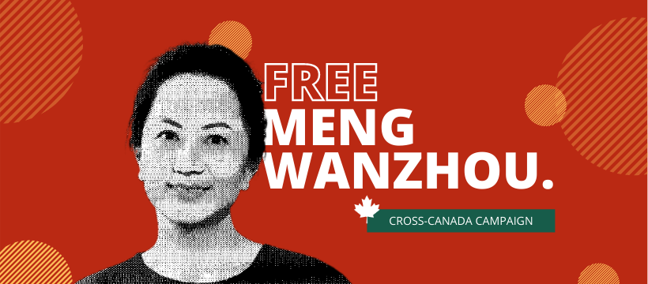

REASON TO CELEBRATE: MENG WANZHOU RELEASED!

The Cross-Canada Campaign to FREE MENG WANZHOU is very pleased that Madame Meng has been released after nearly three years of unjust detention in Canada and has returned home safely to China, to her family, and to her duties as CFO of Huawei, which employs 1300 workers in Canada. She rightly received a very warm welcome by the public at the courthouse in Vancouver last Friday and at the airport in Shenzhen, China.

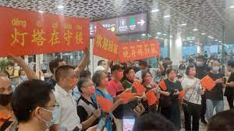

Celebration at Shenzhen Airport

We reiterate that Madame Meng should never have been arrested in the first place. Our organization has been the voice of tens of thousands of Canadians who were appalled that the Trudeau government could sink to the depths of being the henchman in the political kidnapping of an innocent Chinese businesswoman to be used by the Trump Administration as a “bargaining chip” in his trade war with China. We note that many other western countries such as Belgium, Mexico, and Costa Rica refused the US request to extradite Madame Meng and hold her as a hostage for Trump.

Ms. Meng’s arrest was a major mistake on Trudeau part’s because it torpedoed fifty years of good relations between Canada and China, resulting in China curtailing major economic purchases in Canada to the detriment of tens of thousands of Canadian agricultural and fish producers. But the mistake was not out of character: Trudeau’s servility towards Trump embarrassingly called into question the very sovereignty of the Canadian state in front of the entire world, that it would sacrifice its own national interest in the service of its imperial neighbour.

For the record, we note that the US request to extradite Madame Meng was based on the false premise of US extraterritoriality, that is to say, attempting to exert non-existent US jurisdiction over dealings between Huawei, a Chinese high-tech company; HSBC, a British bank; and Iran, a sovereign state, none of whose dealings (in this matter) took place in the USA. By requesting Ms. Meng’s extradition from Canada to the USA, Trump was also sending a signal to global political and business leaders that the US would continue to enforce its unilateral and illegal economic sanctions on Iran which were supposed to have been lifted under UN Security Council Resolution 2231 when the JCPOA (Iran Nuclear Deal) came into effect on January 16, 2016. (The US withdrew from the JCPOA in 2018 before the arrest of Ms. Meng.) The Meng Wanzhou case was always about the US attempt to achieve dominance over the entire world.

Our Campaign applauds Meng’s legal team which doggedly cut to shreds the Crown’s case for the extradition of Madame Meng, to the point that, after securing the release of 300 pages of HSBC bank documents, it was able to demonstrate to Justice Holmes, to the media, to Trudeau’s cabinet, and the entire world that no fraud was ever committed by Madame Meng or that damages were suffered by the bank. With its case in tatters, the US Department of Justice had to resort to offer Ms. Meng a very rare (in the USA) deferred prosecution agreement in which she pleaded not guilty to all charges, after which the US government withdrew the extradition request. It also appears that no fines or compensation will be paid by Ms. Meng or her company to US authorities. No wonder then that the US and Canadian governments scheduled the prisoner exchange for a Friday afternoon, the nadir of the weekly news cycle!

Clearly, the US plan to jail Madame Meng for decades on trumped-up charges of wire and bank fraud and to crush Huawei has suffered a major setback. It was also a setback for US attempts to exert extraterritorial control over other countries, such as China, and for its attempt to strangle the economies of countries, such as Iran, with coercive economic measures. The release of Meng Wanzhou was a clear a win for all those governments and peace organizations working to stop the Western practice of slapping unilateral, illegal, economic sanctions on those countries of the world uncompliant with US foreign or economic policy.

Evidently, there were long discussions behind the scenes between Canada, China, and the USA over the surprising prisoner exchange that took place last Friday afternoon. If it took the return of the Two Michaels to secure the release of Meng Wanzhou, then it was all to the good. We, in the peace movement, always support talks and diplomacy over arms buildups, demonization, and military aggression.

We suspect that, in extending an olive branch to Canada in returning the Two Michaels, China wishes to remove a major irritant and to reset relations with Canada on a positive footing. We hope the Trudeau government gets the message eventually. Right now, it is still accusing the People’s Republic of hostage diplomacy while refusing to acknowledge that Canada initiated this political crisis by arresting Meng Wanzhou in the first place. The Trudeau government should instead reciprocate to China’s olive branch by taking a more independent course in foreign affairs, involving multilateralism, disarmament, and peace, rather than unilateralism, arms deals, and war. Domestically, it could abide by relevant World Trade Organization rules, rebuff pressure from the US government, and finally allow Huawei Canada to participate fully in the deployment of the Canadian 5G network. 1300 highly-paying Canadian jobs are at stake.

What happened to Meng Wanzhou should never be allowed to happen to other citizens of the world. We note that Venezuelan diplomat Alex Saab continues to languish under strict house arrest in Cabo Verde, Africa, the victim of a US extradition request because of Saab’s activities to secure food relief from Iran for Venezuela (subject to unilateral and illegal Canadian & US sanctions), while the US torture base at Guantanamo, Cuba, continues to operate, holding prisoners illegally rendered there from all over the world.

Finally, we wish to thank all of our supporters across Canada and around the world for your active support and donations. We will wait and see if all of Ms. Meng’s charges are duly dropped by Dec. 1, 2022.

For more information, please contact Ken Stone at 905-383-7693, 289-382-9008, or at kenstone@cogeco.ca.

- 30 -
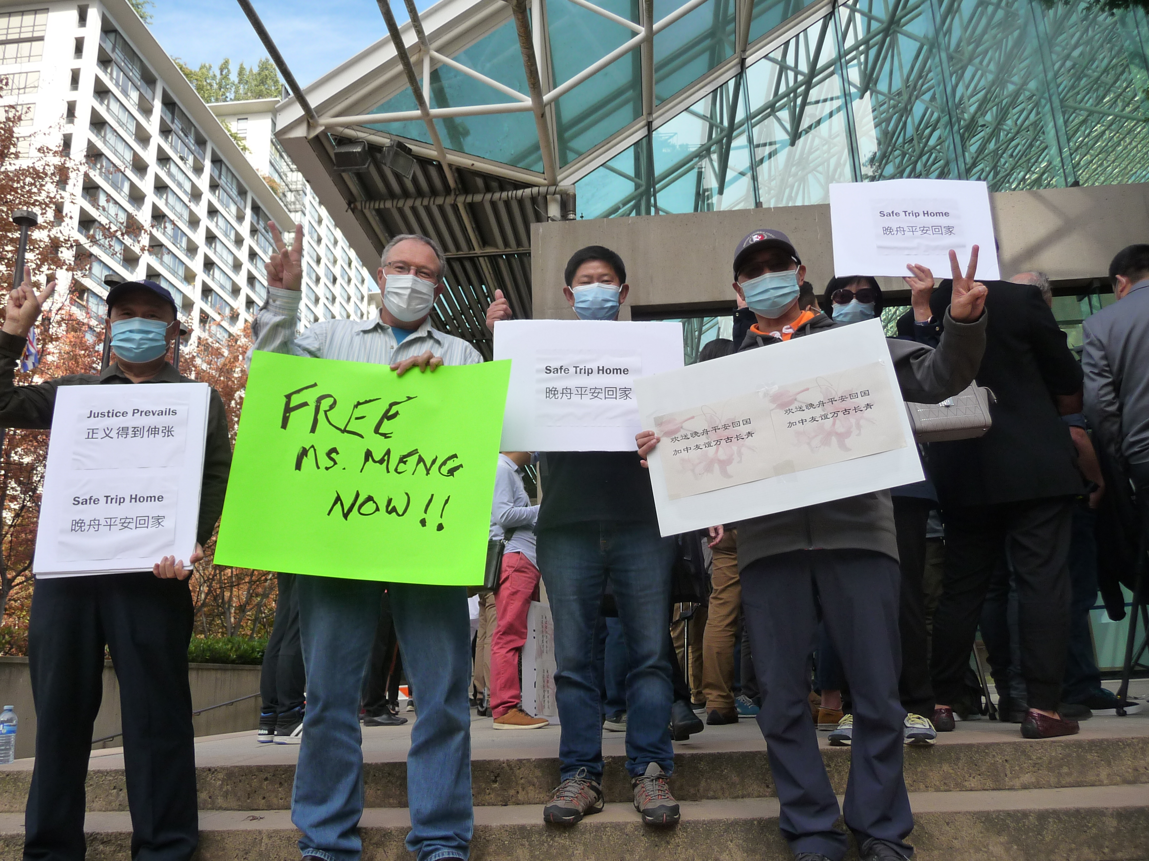
The scene at the Law Courts in Vancouver yesterday as Meng Wanzhou was released from custody.

