TRANSCRIPT – “Bagasora was not guilty of conspiracy to commit genocide”

The following is a transcript of the Taylor Report interview with John Philpot on October 4, 2021. This interview was entitled, “Court Said Bagosora was not guilty of conspiracy to commit genocide.” The audio of that interview can be found here:
https://soundcloud.com/taylor-report/bagosora-was-not-guilty-of-conspiracy-to-commit-genocide
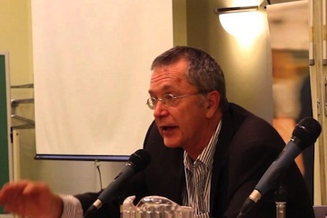

Transcript

Bagasora was not guilty of conspiracy to commit genocide – October 2021

Mainstream Media Got the Story Wrong

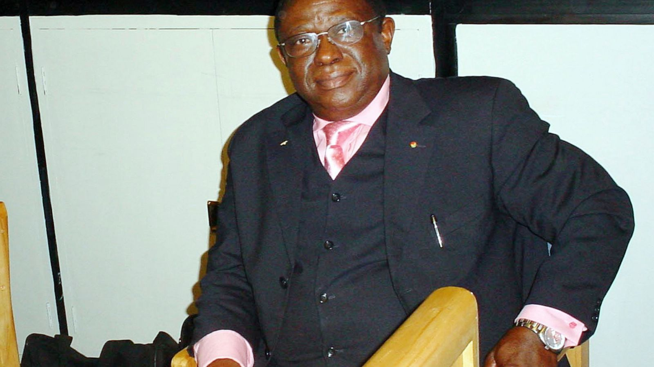
The full text of the transcript follows, below:

Welcome to the Taylor Report – CIUT 89.5 FM (Canada)

PT - We are joined by John Philpot, a distinguished lawyer from Montreal who represented the accused before the International Criminal Tribunal for Rwanda. We want to talk to John todat because the leading personality in the Tribunal - you can almost say a target of the prosecution – Colonal Théoneste Bagasora, has died recentlly in Mali at the age of 80 and because the Western media in their coverage has been using a very inflammatory language about the Colonel which in my view is not accurate. Fortunately we have John Philpot who was in the courtroom many times and has been very familiar with the tribunal and the cases since the beginning. John, welcome to the programme.
JP -Thank you. We are all sadened by the death of this fine man.
PT- Well I think that’s a good note to start with because when we read the headlines, the NY Times called Colonel Bagasora the « architect » of the genocide, others said he was the « kingpin » of the genocide, or said the « mastermind » - I guess that’s the favourite one. Now I was in the courtroom myself for the testimony of general Dallaire on the matter. His name is coming up in relation with Bagasora and the Canadian media is making a link between the two as if there is some of a good guy-bad guy story. Now you’ve just described the Colonel in positive terms, tell us about what the court said on the issue of the « mastermind », the « conspirator », the « organiser », etc.
JP- He had a long trial, was very well defended and after 7 or 8 years of trial he was found not guilty of conspiracy and that was the key finding. For the conspiracy to commit genocide he was acquitted and this tribunal spend one or two billion dollars, they spent a lot of money, they had a lot of investigators, they made a tremendous effort to try and convict mister Bagasora of minding the horrible events which happened in Rwanda and the prosecutor lost despite all the efforts that the UN put behind the prosecutor.
He was found guilty at the trial of ordering some killings, in different localities, and on appeal he was cleared of ALL individual acts, that is ordering to kill someone or, for exemple, ordering his underlings– which he didn’t have - to kill people, he was acquitted of all those. He was only found guilty of being negligent because he should have known and he had to know that his underlings were going to carry out some killings in those 3 days from the 7th to the 10th of April 1994. So he was found guilty of something you might call « criminal negligence », saying that « should have known », and this doesn’t event exist I don’t think in Canadian law. Here he would have been acquitted because that’s not a crime in Canadian law. And on appeal they reduced his sentence from life to 35 years which to me is much too much.
His trial was a relative victory against the claim of the genocide being planned and organised by a senior military figure.
PT- Yes it is so stricking. They accused the four – there were four colonels - and the were allegedly conspiring and you just laid out that at the end of the day the charges against Bagasora were « command issues » or « should have known », etc. , and in the case of General Kabiligi - he was a general – who was allegedly one of the conspirators, he was completely acquitted …
JP - …because he wasn’t there !

PT- I want to read to you the words of someone from the CBC radio programme « As it happens » introducing their interview with General Dallaire about Col Bagasora. They begin saying « In the words of Romeo Dallaire, Bagasora was the kingpin of the Rwandan genocide and the court that sentenced Col Bagasora to prison agreed ». So Dallaire said he was a kingpin and the court agreed, said the CBC announcer. But you just said that they didn’t agree !

JP – No, of course not, they had no evidence. I repeat myself, after spending a large amount of money to try and prove it, and the judges had quite a trend to accept the prosecutors’views, but the defence proved, raised more than a raisonnable doubt in my opinion, that this wasn’t true and he was acquitted of conspiracy. And in fact, the global conspiracy was not accepted by ANY judgment.

There were some minor agreements, alledged conspiracies in localities where the accused got together and planned but the national conspiracy did not exist. The alledged planning never existed. And it’s shocking when you think that this tribunal said certain things and all the media and all the so-called think-tanks and all the so-called intellectuals still carry on with this story, they have no respect for the rule of law and the rule of law at the ICTR was biaised in favor of the prosecution, but even then it didn’t pass the test.

PT - I assume it is - for lawyers like you and others who follow this - rather frustrating to go through the courts, hear the testimonies and at the end of the day the reporters go back to telling the same stories they had in 1994, so one can ask « why did you bother to have a trial, the are just going to repeat the same lies ». Maybe the conclusion about Colonel Bagasora is that because he has the title of Colonel, people assume that he was a major military leader. What was is role ?

JP - He was the head of the Ministery of Defense, he was not even a soldier at the time, he was a political figure and he was not in the army, he didn’t do anything in the army, and they had to make a construct saying that he had the effective control but he was not a soldier at the time.

PT - That’s because his Minister was abroad, he was what they call the cabinet officer, so he had to assume responsability, right ?

JP - He had some responsibility, he was involved in some of the negociations, but he was not in charge of the army, he was not acting and giving orders to the army.

PT - I wan’t to make sure we also talk about another matter that came up : the case of your client, mister Zigiranyirazo. When his case came up there was a similar attention to it be because he was called Mister Z and he already had a reputation in Canadian media and Belgian media. They had created the idea that there was a group called Zero Network. Now I was surprised to hear Dallaire talking to « As it happened » referred to the Zero Network and said that Bagasora was a part of it and also that the French took the leading members of the Zero Network out of Rwanda in the first 48 hours. Your client was the one individual that it was claimed of him that he was a leader or member of the Zero Network. Tell us about him.

JP - Well, Mister Zigiranyirazo was alledgedly head of the Zero Network, also called the Akazu, a little group of people around the President. They alledgedly conspired prior to the attack on the plane to exterminate Tutsis and led the conspired to exterminate Tutsis after the plane was shot down. Well he had a trial which lasted about 6 years of procedures and he was a acquitted on everything. And the opposition parties came to the court and testified that these terms Akazu and Zero Network were simply terms invented by the opposition in the political disputes which began in 1991-92 up until the assassination of Pres. Habyarimana in 1994. So this is all at lies and was not retained by the court. Mr Zigiranyirazo was acquitted of conspiracy and of all the other charges that he alledgedly ordered such and such person to be killed, etc. So their whole organisation of a plan of how this happened pretty much fell apart. This is the story at the ICTR, but the world don’t seem to care, they really don’t seem to care. Stories have been written, books have been written and these people who were acquitted are still sitting as you know in Arusha. Most of them cannot be transferred and cannot go to their families which are based in Europe in general now.

PT - Yes that is one of the great injustices, you have people acquitted, which means they are innocent and should be permitted to be with their families, but the UN that put them on trial doesn’t fight to return them their rights that the declaration of innocence would give them and doesn’t defend them.

JP -That’s a lesson which we should all learn and all lawyers and all interested persons should understand that international criminal law does not have the standards that national legal systems sometimes have. I don’t want to phrase on national legal system but if Phil Taylor is acquitted on drunk driving, he is acquitted and that’s over.

PT - I am very glad we have a chance to talk about this because you were in that courtroom and won that battle. It would be helpful if we could develop some interest in actually making the court records of the ICTR available in the media here. I think it’s bizarre that Dallaire is talking a fairy tale about the Zero group. His credibility in this, in my opinion, is absolutely zero. They did not find that Bagasora was a kingpin, but yet Dallaire is parated as the guy who got it right, but he didn’t get it right on that, he’s talking about a Zero Network you just showed that there wasn’t one, the courts found. Part of the problem is that the legend of Dallaire is confusing everyone, the media here is so protective of him, they don’t actually treat him as a human. Because of his post traumatic stress problems he is like irreprochable. But unfortunately he went into a courtroom and gave evidence of trying to do a lot of damage with his evidence. I wonder, if you look at the judgments, they are saying here that Bagasora’s evidence was somehow crucial, I did not get that sense myself, reading the judgment, that they tought that his testimony had any significant value.

JP - It was not particularly based on it. His acquital was based on the weakness of the prosecution’s evidence, not necessarely on his own evidence, which is a good thing for Mr Bagasora because they were so biaised against him that had the case depended on his testimony they would have just trown it out. But the prosecution evidence was so weak and nonsensical that Mr Bagasora was acquitted. And then they made this artificial construct that he is liable because he should have known the intention of his so-called underlings which weren’t his underlings.

PT - Yes ! Another element that strikes me about the reporting, the journalists did not actually look into the actual trial records or the judgment, they are going by popular anecdotes, and they are very parochial I noticed. For exemple, Dallaire is cited continuously in reference to Bagasora, it’s not mentionned that Colonel Luc Marchal, a Belgian, testified in this case for the defense. He was a major figure, he was in charge of the security for the Kigali sector and the Belgian troups were major part of the drama. Yet here you have everyone saying that Dallaire testified, he didn’t like him, in fact he litterally demonizes Bagasora, he calls him a devil, but they don’t mention that the Belgian Colonel did not have the same view of Bagasora.

JP - Yes, Luc Marchal wrote to me 2 days ago because I wrote a small artical basically about what we are talking today and sent it around to our friends and he wrote to me personnally saying that he is so sad that such lies are propagated, that the media are making all these stories about Bagasora which is contrary to the truth.

PT - Itsn’t it striking ? Here is a man who put himself on a stand, took the oaths and testified for the defense , largely for Kabiligi, but he had a different view of what was going on in Kigali in 1994, April 6th, 7th and 8th. And again just to be clear, Bagosora’s authority ended on the 9th of April. Three days where he actually had authority, some legal responsability !

JP - Yes, exactly !

PT - And the leaders of the verious units of the Rwandan Army were not taking orders from him, they were fighting as soldiers, people forget that the war began on the night of the assassination of the President on April 6th, and two armies engaged on that moment. And since I have mentioned Colonel Luc Marchal, I want to talk about another aspect to that, which is ignored be the media here : Bagasora was given responsibility for the deaths of the Belgian soldiers. Now that has always been highly problematic to my mind and I want to review with you what I know and tell me what you can recall of this.

PT - On the morning of April 7th there was a meeting of the Rwandan Army officers to which General Dallaire was invited – these are allegedly the conspirators in the mind of Dallaire – they have a meeting of 20 or 30 officers at Kamp Kigali. He goes to the meeting and on his way he sees a Belgian UN soldier on the ground in a struggle with Rwandan soldiers and he continued onto the meeting. He says he saw it, he continued onto the meeting. He walked into the meeting with Rwandan Army officers, I don’t think it could have been more than a quarter of a mile from where he saw what he saw and did not say anything until the end of the meeting. I understand you might want to talk about Bagasora being an officer and having some responsibility, but where is Dallaire culpability for not acting himself on behalf of his own fallen soldier ?

JP - Well had he seen what you are just describing, he could have - I am sure he had a radio, he had a driver- he could have intervened and called for immediate intervention to try and protect that person and so he was being negligent, and by the same talking that Mr Bagasora was alledgedly guilty, well Mr Dallaire would probably be guilty of the same negligence.

PT - If it’s negligence, you have at least two officers negligent, anyone who heard about it in a position of authority is culpable to some degree if they did not act.

JP – Absolutely !

PT - And they were not dead at that point, he could have stopped, by that story he would have a good chance of preventing it to happen, he would have had a reasonable chance of preventing the murder of the Belgian soldiers.

PT - Had he stood up among those army officers and said « I have soldiers down here » , that was a diverse group of officers. I have to say my own opinion is that he seems to have been treating them like an enemy, but to what end ? if he didn’t want to trust them to try to save the Belgians then he should have taken the responsibility himself with people he had the command of and see what he could do.

JP - Maybe he had another agenda which is that there was an offense of the RPF on their way north of Kigali, he may have had a second agenda that he wanted the other party, the invadors, to take power, that might have been his plan, his understanding.

PT - We should bring out a rather important detail for all this talk about the evil conspiracy and how they were all devils, how Bagasora was a devil.

PT - Bagasora and Gen. Ndindiliyimana were the two key people at the meeting. Ndindiliyimana was also acquitted of all charges. He (Bagasora) was co-chairing both the meetings that Dallaire attended while the Belgians were being beaten to death, struggling for there lives, and they did something else which doesn’t match the story of the great conspiracy. They chose a new commanding officer for the entire Rwandan Armed forces, Gen Gatsinzy. Who is he today ?

JP - He is in Rwanda, I don’t know whether he is still a military but he did join the RPF, yes.

PT - He joined the RPF and at the time that they appointed him to lead the entire Rwandan Army, gave him command, he was already known to be an officer not being particularly enthusiastic about Habyarimana, and had actually no great interest in the war, but they gave him the job largely out of old rules of seniority, he was the senior commander after Gen. Nsabimana who was killed along with the president.
JP - They brought him from Butare on the 9th I think.
PT - And they gave him command ! This was Bagasora who Dallaire is calling a devil on CBC ! Bagasora chaired the meeting where the chose Gen. Gatsinzy to lead the army. This is pathetic, is it not ?

JP -For sure.

PT - It is high comedy.

JP - I’d like to say something about Mr Bagosora. He is now at the 2/3 of his time in prison and he did not get the lease at his 2/3 of his time, unlike people in the past who were getting it. He wanted to have a few years being free either in Europe or Mali. And he was refused that by the president of the tribunal. I think it’s shocking that they bend the rules and found a way to not let people out, saying, once again, that he did not regret what he had done and pointed out the same thing we point out today about the nature of his conviction. He did not have proper medical care in the last years. It’s very important that we understand that because there is a lot of other aging prisoners and I think it’s important for us to work hard to try and improve medical services. We had some success but with the aging prisoners they have to be treated in the same way an aging prisoner would be treated in a Canadian prison.

PT - Well I think those are all good points. The job before us I believe is to take this strange missionary, quasi theological and racial language out of the mouths of mainstream media who think they can call someone a devil, whom they don’t know, he definitely is not the devil - I understand the devil has his own work. To speak in that way and happily say things like « I shook hands with the devil », like other journalists have repeated, it’s like we are getting in line with this idea of demonization of the African accused. They are all very confortable in saying the most terrible things like « it’s another country, it’s another language, it’s another culture ». As you said and illustrated in your remarks, this is completely inappropriate, it’s an embarrassment to have a tribunal and to go through a whole process only to find ourselves with this kind of insulting and misleading and misinforming talk out of our journalists.
PT - I hope, John, that we can speak to you again in the future about these notions of the Akazu and the Zero Network, because it’s a myth, it’s a legend, and if we are permitted to go on lies about what happened in Rwanda, we will go on.
JP - I know the family would be very happy that you raise these issues.
PT - Thank you.

